

**MATHEMATICS SPECIALIST 3,4**

**TEST 3 SECTION ONE 2016**

**NON Calculator Section**

**Chapters 4,5**

**Name________________________________ Time: 15minutes**

**Total: 13 marks**

**Question 1 [5 marks]**

The diagram to the right shows parallelogram ABCD where 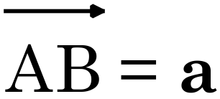 and 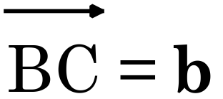.



Point X divides DB internally in the ratio 2:1.

Point M is the midpoint of AB.

1. Show that 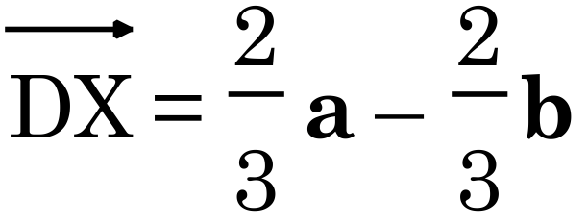 . [1]
2. Find  in terms of **a** and **b**. [1]
3. Prove that points M, X and C are collinear. [3]

**Question 2 [6 marks]**

Given the vectors, **a** = 2**i** – 3**j** + **k**, **b** = 4**j** – **k**  and **c** = **i** – **2j** – 3**k**, find:  
  
a) 3**b** – **a** [1]  
  
  
  
  
  
b) ⏐**c**⏐ [1]  
  
  
  
  
  
c) the vector equation of the line passing through the point with position vector 3**b** and  
 the point with position vector **a**. [2]

d) the vector equation of the plane passing through the point with position vector **b**  
 and normal to the vector **c**. [2]

**Question 3 [2 marks]**

Find  given that 